
Restaurant
Business Plan

Getting Started

A restaurant business plan provides you with the opportunity to organize your vision and ensure that nothing is overlooked when opening a restaurant for the first time, reworking your concept, or opening a new location. When you're tangled in the weeds of construction, licensing, staffing, and other operational stressors, the plan will act as a roadmap to help you stay focused.

Instructions for Your Business Plan Template
Start with the cover page. Insert your company logo as well as your name, address, phone number, and email address.

Then, continue to the business plan itself. As you’re filling out each chapter in this business plan template, there are prompts and directions in italics below each section header. Your writing starts in the regular text below the prompts. Simply delete “Start...” and begin writing. Each restaurant concept is different, which is why we chose to give you space to explain your individual concept in detail. There are also a few interactive “fill-in-the-blank” parts of this template, such as the management headshots and the competitive matrix.

Finally, when you’re ready to show your business plan to the world, simply delete everything in italics, as well as the first page and the last page. Your business plan will start with the cover page and end with your financial analysis. To print, click File > Print and to download, click File > Download As and choose your preferred format.

Ready? Let’s get started!



Alex Harper
101 Main Street, Chicago, IL
555-555-5555
jow@yum.com

Table of Contents

1. Executive Summary
2. Company Overview
a. Restaurant Concept
b. Restaurant Service Model
c. Sample Menu
d. Design and Layout
e. Management Team
3. Industry Analysis
a. Target Market
b. Market Positioning
c. Location Analysis
d. Competitive Analysis
4. Marketing Plan
a. Customer Database
b. Loyalty Program
c. Community and Charity Involvement
d. Public Relations
e. Advertising and Social Media
5. Operations Plan
a. Staffing and Training
b. Work Health and Safety Standards
c. Staffing Model
d. Customer Service Policies and Procedures
e. Suppliers
6. Financial Analysis and Growth Plan
a. Investment Plan
b. Projected P&L Statement
c. Break-Even Analysis
d. Expected Cash Flow

Executive Summary
The executive summary is the first section included in any business plan. It acts as both the introduction to, and the summary of, your entire idea. This section should introduce the key elements of what will be discussed throughout the business plan. It should present a complete and concise summary that is designed to catch the reader's attention and entice them to explore the rest of the plan. An executive summary includes things like the mission statement, proposed concept, how you will execute on the plan, overview of potential costs, and the anticipated return on the investment. Potential investors will look here first to see your plan for a successful future - so make sure it’s good!

Start…

Company Overview
In this section, begin to explain the high-level elements of the proposed business. The company overview introduces information about the ownership structure, location, and business concept. Outline the vision for the guest experience. Describe the brand. Identify the service model, design, layout, general theme, and unique aspects of the overall concept.

Restaurant Concept
In this section, give an overview of your restaurant concept. What is the defining theme? Is it casual or formal? Describe your brand, what you’re offering, and how you’re differentiated from the competition. What kind of food are you offering? What is the price point? This section doesn’t need to go into specifics – you’ll talk about your menu, finances, and specific models further down – so keep this high-level.

Start…

Restaurant Service Model
Service models in the restaurant industry are ways of preparing, presenting, and distributing food to your guests. Each model will have a different result on your revenue. In this section, explain which service model your restaurant will be using and how it will work at your concept. Here are a few popular models to consider using:
- Continued Service: The new continued service model uses restaurant technology to let guests have more control over their dining timeline. The restaurant still has servers but relies on either Order and Pay technology or handheld POS systems to allow guests to continue to order from their phones or staff members as they pass by.
- Half-Service, Hybrid Service, or Fast-Fine: Hybrid or half-service falls somewhere between table service and counter service. Guests are seated by a host, but then they get up and order food and drinks themselves. They’re given table numbers, and their food and drinks are brought to their table.
- Kiosk Self-Service: Usually put to work in fast-casual or fast-food restaurants, kiosks can speed up service and drastically lower your labor costs. They can make for a more seamless customer experience, and they free up time your staff can use to serve up exceptional hospitality and amazing food.
- Build-Your-Own Service: The build-your-own model has become the norm in many fast-food restaurants due to the increased demand for customization. Subway, Chipotle, Sweetgreen, and Blaze Pizza are all examples of this model, but independent businesses have begun to adopt it as well, even in full-service restaurants.

Start…

Sample Menu
Share a sample menu to be used at your restaurant, including separate menus for breakfast, lunch, dinner, and drinks. Outline your strategy for menu costing, menu engineering, and menu design, including how you will test your menu over time to improve profits. Take the Menu Engineering Course for more tips and to learn more.

Start…

Design and Layout
Discuss how the design and layout of your restaurant will complement its brand. What kind of silverware and plateware will you use? What uniforms will your staff be wearing, if any? What kind of ventilation and lighting will your restaurant be using, and why? How will the functional aspects of the restaurant - the refrigerator, the storage areas, the kitchen - operate and in what capacity?

Start…

Management Team
Share the names of the people on your executive team, as well as their shared and individual responsibilities. Examples: CEO, COO, Managing Partner, General Manager, Kitchen Manager, Chef, Director of IT, etc.

Start...

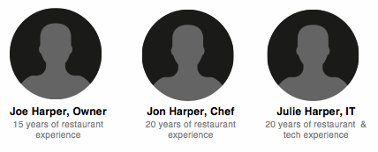

Industry Analysis
Describe the existing conditions in the general market and in the specific location or area that you plan to open the restaurant. This section could cover things like the growth of the local economy and industry, infrastructure projects, nearby business and residential areas, and average traffic counts in the area. This section could also include your unique positioning – showcasing your ability to adapt and thrive in a sometimes-oversaturated marketplace.

Target Market
The restaurant industry is an extremely competitive landscape, so finding a strategic niche is imperative. You should have a strong idea of who your restaurant will attract and who will become your repeat customers. Describe the target market and how it compares to the restaurant industry as a whole in terms of diner demographics, characteristics, and behaviors.

Think through what your customers’ behaviors might look like after the COVID-19 pandemic. Will they be ordering online more often? Prefer a contactless experience? Want to eat outdoors? The pandemic is temporary, but some behaviors that have developed from the pandemic will likely become long-lasting changes in the industry as a whole. For example, post-pandemic guests will continue to expect a seamless digital experience from their favorite restaurants. Technology can help ease these changes in guest behaviors, such as a solid online ordering platform, contactless payment, and order and pay at the table.

Start…

Market Positioning
What products are you selling – beyond your day-to-day menu? You want to show that you’re offering something unique that other restaurants might not have. Talk about any unique products, innovations that showcase your adaptability, or anything interesting that sets you apart from the competition.

The COVID-19 pandemic inspired many restaurateurs to shift their concepts in creative ways. Many of those new strategies will continue to be profitable post-pandemic. Here are a few ideas to inspire you:

- Retail products: This could include sweatshirts and tote bags with your logo, or some of your best-selling items for individual purchase. Do you have a popular salsa or a famous pie? A favorite cookbook? Think about selling your best items separately for customers to buy.
- Make-at-home meal kits: Offering takeout family meals has been popular throughout this year to increase ticket size and bring in more online ordering revenue. You can offer boxes for takeout with everything a family would need for dinner – either DIY style or ready-to-eat.

- Cocktails to go: Many states are now allowing take-out alcohol. Think about offering your drink menu to go or a happy hour deal with half-priced appetizers with each drink purchase.

- Subscription clubs: Try offering a specialty item as a part of a monthly subscription for a set price. This can be cheese, wine, meat, chocolate, or really anything that your guests seek out. You can also have onsite pickup if you don’t want to deal with shipping.

Take full advantage of your online ordering platform and include these items for sale there, too.

Start…

Location Analysis
Focus on the general area or city you plan to locate the new restaurant and why you chose that specific area. Note things like growth of the local economy, large citywide events, and infrastructure projects nearby. Compare the existing market conditions to your intended target market. Potential restaurant investors will look at this section of the business plan carefully to make sure that the market in the proposed location aligns with the ideal customer profile.

Start…

Competitive Analysis
What other businesses are in the proposed area? This section should explain the existing competitive landscape: the number of other restaurants in the area, paying particular attention to restaurants with similar concepts. Investors will want to understand the specific aspects of your concept that will give you a competitive advantage.

Fill out this competitive matrix to get started:

 | Seats | Meals | Pricing | Hours | Notes
Your Restaurant | 40 | Lunch & Dinner | * | 12:00 pm - 12:00 am | Bar & kitchen
Neighboring Restaurant 1 | 20 | Breakfast &  Lunch | ** | 6:30 am - 2:30 pm | Outdated menu
Neighboring Restaurant 2 | 50 | 3 meals/day | *** | 7:00 am - 9:00 pm | Old building / no parking / slow service

Start…

Marketing Plan
The marketing plan explains your marketing strategy and the tactics you will rely on before and after the restaurant is operational. Perhaps you will rely more on public relations and advertising before the restaurant opens and focus on things like social media, loyalty programs, building a customer database, and four-wall restaurant marketing once the business is operational.

Customer Database
Whether you’re contacting members of your loyalty program or completely new customers, restaurant email marketing is an incredibly efficient way to encourage repeat visits. Gathering email addresses is the first step.

In this section, explain your email marketing strategy. How will you collect customer email addresses and learn about their behaviors at your restaurant, such as average check sizes and frequency of visits? Once you grow an existing customer database, what is your plan to engage guests to become loyal customers? What kind of campaigns do you plan to run?
With Toast, you’ll automatically grow your email list when new guests place orders for takeout or delivery, or when they’re dining in-store and opt to sign up for your loyalty program. This type of technology streamlines your guest engagement.

And with Toast Marketing, you can automate email campaigns to send out news, promotions, menu updates, or whatever you think will drive traffic to your restaurant. Learn more about Toast Marketing here.

Start…

Loyalty Program
According to a study by LevelUp, when a customer is close to unlocking their loyalty reward, they spend 39% more than usual. Loyalty programs are a way to use customer data to drive repeat visits. With Toast Loyalty, guests automatically accrue points whether they dine in-store or place an order online. Loyalty accounts linked to a guest's credit card makes this easy.

Plus, you can combine loyalty and email, and use the insights available from your customers’ loyalty analytics to send targeted email campaigns to those who are close to reaching rewards or are close to being considered loyal.

In this section, explain how you’ll create a restaurant loyalty program that’s easy to join and will give guests an immediate incentive. Will guests be able to track their rewards or points on their phone? Will they be using a loyalty card, or will their credit card be tied to their rewards account? What kinds of rewards will you offer guests?

Start…

Community / Charity Involvement
Philanthropy should definitely be an integral part of your restaurant marketing plan, especially if you’re opening a new restaurant and starting a new brand. According to a this study, 72% of consumers would recommend a business that contributes to charity over one that doesn’t. Partnering with a charitable organization can boost employee morale, build on your restaurant group’s brand and image in the community, slightly ease your tax burden, and make a major difference in the lives of many.

Start…

Public Relations
In order to penetrate your target market, you will need to get in front of the right people: your would-be customers. Highlight your PR strategy in your restaurant business plan, including resources you may send to newspapers and other publications, such as a one-page press release about your restaurant opening or a manifesto of your restaurant brand. Create a goal for exposure in your local market as well as on a national scale.

Start…

Advertising and Social Media
Today, social media is an inevitable part of running a business. Your guests are on social media, so you should be, too. And with some promotion, you can be sure that your guests will be tweeting, posting, and Instagramming about your restaurant online in no time. Share your plan for Facebook, Twitter, Instagram, Yelp, Google, and other social networks, including how you’ll build a digital community and how you’ll advertise on these platforms in the future.

Start…

Operations Plan
Here you should paint a picture of how the restaurant will operate day-to-day once it is operational. Include in this section:

Staffing and Training
Which staff positions will you need and how many people do you expect in each of the different roles? What is the approximate pay for each position? How do you plan to recruit staff and what are the hiring criteria for each role? And, once you hire your staff, what’s your plan for team management? Think about how you’re going to handle scheduling, payroll, labor reporting, and performance insights.

Technology is also essential here – by integrating your payroll and point of sale systems, the two can work together to make payroll faster and smoother, like with Toast Payroll and Team Management.

Here’s a quick list of things to consider:

● Recruitment procedures
● Interview questions
● Application form
● Job Descriptions
● Induction Procedures
● Employee Handbook
● Wage procedures
● Pay slips
● Time sheets
● Occupational Health and safety signs and procedures

Start…

Work Health and Safety Standards
Cleanliness is more important to restaurant operations than ever before. By putting the right food safety systems and precautions in place, you’ll keep your team and guests safe. In this section, outline your cleaning procedures, food safety, and health standards. Every state and country has different rules regarding inspections and health code violations. Learn more about your specific regulations here and recommended safety measures from the WHO here.

Start…

Staffing Model
There are a growing number of ways to manage, compensate, and reward restaurant teams. But the management and staffing model you choose affects your restaurant staff — and your ability to hire and retain them — in pretty significant ways.

In this section, describe what your staffing model will look like at your new restaurant. Here are a few examples to get you started:

- Gratuity-free: The gratuity-free model — also sometimes referred to as the “tip-free” or “hospitality-included” model — is a system where servers don't accept tips and are instead paid an hourly living wage, often plus employee benefits like health insurance.

- Profit-sharing: Profit-sharing (also known as revenue-sharing) is an incentive-based system in which staff receives additional payment — alongside regular compensation and bonuses — depending on the restaurant’s profitability.

- Open Book Management: Open-book management is a system where restaurant management shares the finances of the business with its employees. This lets employees see how their work contributes to revenue and helps them have a greater understanding of their business impact.

Start…

Customer Service Policies and Procedures
How do you expect to provide a favorable and consistent guest experience? What are the specific service values, policies, and procedures you will put in place, and how will they be enforced or encouraged?

Start…

Suppliers
How will you track sales and inventory, manage labor, and control cash? How will you process credit cards, and which restaurant tools will you use? From which vendors will you buy your food? If applicable, include a cost analysis of various food vendors or various technology options.

Start…

Financial Analysis and Growth Plan
The financial analysis is often one of the final portions of a business plan. Investors expect to see a breakdown of how you plan to spend their investment in the first year and a comparison of the anticipated costs and projected revenue. There are a few major elements you should be sure to include in this section.

A note on funding: It’s notoriously difficult to get a bank loan for a restaurant business, but loans are available to help fuel your growth. Here are a few options best suited to restaurateurs:

- Toast Capital: Toast Capital offers access to loans that can support your business and staff. Funding is fast with flexible automatic repayment, and you can get access to funds in just a few days. The program is restaurant-specific and designed with your interests in mind.
- Equipment Loans: Talk with your bank or provider to explore loans expressly for kitchen equipment and restaurant technology. Many point of sale providers, including Toast, offer 0% interest financing to offset the initial cost of the technology.
- Lines of Credit: If you’re approved for a business line of credit through your bank, you’ll get a maximum credit amount. But you will only pay what you use, of course. A line of credit functions not unlike a credit card, in that it constantly revolves. As you pay your balance, you’ll have more credit to draw on for future expenses.
Find more information on how to get funding for your restaurant here in The Complete Guide to Restaurant Financing and Loans.

Investment Plan
Here you explain the initial investment you are hoping to receive and how you plan to spend that investment during the first year. This will usually include kitchen equipment, general supplies, furniture, payroll, legal fees, marketing, and some working capital.

Start…

Projected P&L Statement
The business plan is created long before the restaurant actually opens, so creating this profit and loss statement will require you to make a number of assumptions. You can make educated guesses about the various costs and sales elements included in a P&L based on the size of the restaurant, your target market, and the existing market in the area you’ve selected for your restaurant. You can use this interactive P&L template and guide to learn more about profit and loss statements and to create one for your new restaurant.

Start…

Break-Even Analysis
This one is pretty straightforward. Investors will want to know how much revenue you will need to bring in each month in order to break even once all of the various overhead and operational costs are factored into the equation. There are always going to be some variable costs, so make a note of what you expect that to be in your analysis.

Start…

Expected Cash Flow
Your cash flow will depend on how often you expect to purchase inventory, the size of your staff and payroll, and the payroll schedule. Once your restaurant is operational, some months will be better than others. The cash flow analysis should help investors understand that, based on your expectations, your restaurant will be able to support itself even in the less fruitful months without requiring additional investments.

Start…

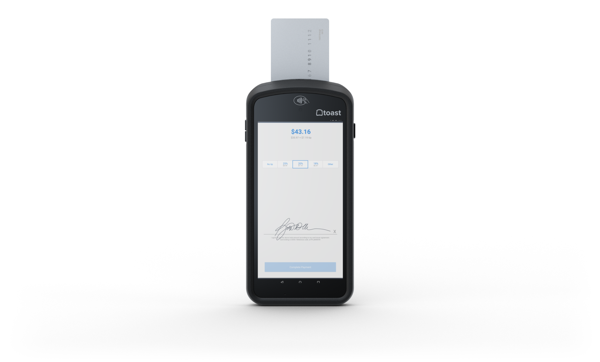

Built to make restaurants better

Toast gives your restaurant the technology you need to succeed in
today's fast-paced environment.

Schedule your free demo

DISCLAIMER: This content is for informational purposes only and is not intended as legal, accounting, tax, HR, or other professional advice. You’re responsible for your own compliance with laws and regulations. Contact your attorney or other relevant advisor for advice specific to your circumstances.

